**Smartwatch Data Analytics**



**Name: Ayan Kanti Das**

**Roll No: 21051386**

**Branch: Cse**

**Cse 32**

**Acknowledgement**

**I would like to express my sincere gratitude to Mrs. Sarita Tripathy for her invaluable guidance and support throughout the duration of my smartwatch data analytics project. Her expertise, dedication, and encouragement have been instrumental in shaping my understanding and approach towards this challenging field.**

**Mam’s insightful feedback, patience, and unwavering commitment to my learning have significantly contributed to the success of this project. Her mentorship has not only enriched my technical skills but has also inspired me to strive for excellence in my academic pursuits.**

**I am deeply appreciative of Mrs. Sarita Tripathy's tireless efforts in fostering a stimulating learning environment and her willingness to go above and beyond to ensure my academic growth and success. Her passion for teaching and dedication to her students have left an indelible mark on my educational journey.**

**I extend my heartfelt thanks to mam for her unwavering support and guidance, which have been instrumental in my learning and development.**

**Content**

* **Abstract**
* **Introduction**
* **Objective**
* **Implementation**
* **Code**
* **Conclusion**

**Abstract**

**This abstract encapsulates a detailed exploration into the realm of smartwatch data analytics. The study delves into the vast array of data generated by smartwatches, encompassing physiological measurements, activity tracking, and other relevant metrics. Through a systematic approach, the research aims to extract meaningful insights from this data, employing various analytical techniques such as machine learning algorithms, statistical analysis, and data visualization methods. The findings shed light on patterns, trends, and correlations within the smartwatch data, offering valuable insights into individual health and lifestyle behaviours. Furthermore, the study discusses the potential applications of smartwatch data analytics in healthcare, fitness monitoring, and personalized recommendations. By leveraging the power of smartwatch data analytics, this research contributes to advancing our understanding of human behaviour, enhancing healthcare practices, and promoting well-being in society.**

**Introduction**

**In recent years, the proliferation of wearable devices, particularly smartwatches, has revolutionized the way we monitor and track various aspects of our lives, including physical activity, sleep patterns, and overall health. Smartwatches have become ubiquitous companions, offering users real-time access to a wealth of data about their well-being and daily activities. This surge in wearable technology has generated vast amounts of data, presenting both opportunities and challenges for meaningful analysis and interpretation.**

**The field of smartwatch data analytics has emerged as a dynamic and interdisciplinary domain, encompassing techniques from data science, machine learning, signal processing, and healthcare. The rich and diverse nature of smartwatch data presents exciting possibilities for extracting valuable insights into individual health behaviours, lifestyle patterns, and overall wellness.**

**This introduction sets the stage for exploring the multifaceted landscape of smartwatch data analytics. We will delve into the various types of data collected by smartwatches, ranging from heart rate and step counts to sleep quality and stress levels. Moreover, we will examine the methodologies and tools employed to analyse and make sense of this data, including statistical techniques, machine learning algorithms, and data visualization approaches.**

**Furthermore, we will discuss the potential applications and implications of smartwatch data analytics across different sectors, including healthcare, fitness, and personalized recommendation systems. By harnessing the power of smartwatch data analytics, we can gain deeper insights into individual health dynamics, develop more effective interventions for chronic diseases, and promote healthier lifestyles.**

**Through this exploration, we aim to underscore the transformative potential of smartwatch data analytics in shaping the future of personalized health monitoring, preventive care, and well-being enhancement. This journey into the realm of smartwatch data analytics promises to unlock new avenues for innovation, research, and societal impact.**

**Objective**

**The primary objective of this smartwatch data analytics project is to explore and analyse the daily activity data collected from users wearing smartwatches. By leveraging various analytical techniques and visualization tools, we aim to gain insights into users' activity patterns, calorie expenditure, and sedentary behaviour. The project encompasses the following main themes:**

* **Data Exploration:**

**Load the daily activity data from the provided CSV file.**

**Understand the structure and characteristics of the dataset.**

**Preprocess the data, handling missing values and converting date columns to appropriate formats.**

* **Descriptive Statistics:**

**Compute descriptive statistics to gain an overview of key variables such as total steps, active minutes, sedentary minutes, and calories burned.**

**Visualize the distribution and summary statistics of these variables using histograms, box plots, and descriptive tables.**

* **Exploratory Data Analysis (EDA):**

**Explore the relationship between different activity metrics, such as total steps, very active minutes, and calorie expenditure.**

**Investigate how activity levels vary across different days of the week and visualize these patterns using bar charts and pie charts.**

**Analyse trends in sedentary behaviour and identify potential correlations with other activity metrics.**

* **Visualization and Interpretation:**

**Utilize scatter plots, regression analysis, and interactive visualizations to uncover insights into the relationship between calorie expenditure and total steps.**

**Visualize the distribution of active minutes across different activity levels and days of the week using bar charts and pie charts.**

**Interpret the findings and discuss the implications for understanding users' activity behaviours and promoting healthier lifestyles.**

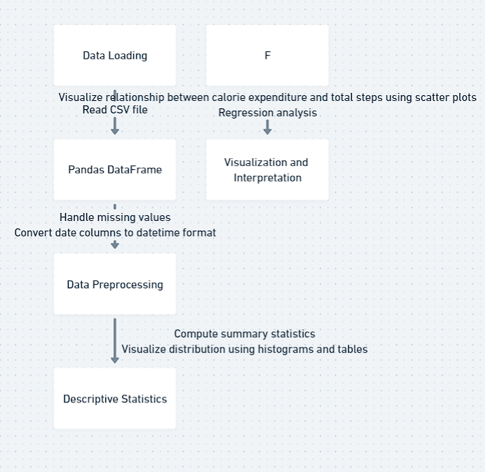

**Implementation**

1. **Importing Libraries:**

**Import the necessary libraries including pandas, NumPy, matplotlib.pyplot, plotly.express, and plotly.graph_objects.**

1. **Reading Data:**

**Read the CSV file containing the data into a panda DataFrame.**

1. **Data Exploration:**
2. **Display the first few rows of the DataFrame to understand its structure using ‘data.head()’.**
3. **Check the shape of the DataFrame using ‘data.shape’.**
4. **Find the number of unique IDs in the dataset using ‘data['Id'].nunique()’.**
5. **Select relevant columns for analysis and store them in a new DataFrame.**
6. **Handling Missing Values:**

**Check for missing values using ‘data.isnull().sum()’ and handle them if necessary.**

1. **Data Preprocessing:**
2. **Convert the 'ActivityDate' column to datetime format using ‘pd.to_datetime()’.**
3. **Create a new column 'TotalMinutes' by summing up minutes spent in different activity levels.**
4. **Statistical Analysis:**

**Compute descriptive statistics for the dataset using ‘data.describe()’.**

1. **Visualization with Matplotlib and Seaborn:**
   * 1. **Create a scatter plot showing the relationship between 'Calories' and 'TotalSteps' with 'VeryActiveMinutes' as size using sns.scatterplot() and sns.regplot().**
     2. **Display the plot using ‘plt.show()’.**
2. **Visualization with Plotly:**

**Create a pie chart showing the distribution of different activity levels using ‘go.Pie()’ and ‘fig.show()’.**

1. **Analysing Weekly Trends:** 
   * + - **Extract the day name from the 'ActivityDate' column and create a new column 'Day'.**
       - **Create a grouped bar chart showing activity minutes for each day of the week using ‘go.Bar()’ and ‘fig.show()’.**

**10. Visualization of Inactive Minutes:**

* + - * **Create a pie chart showing the distribution of sedentary minutes across different days using ‘go.Pie()’ and ‘fig.show()’.**

**11. Visualization of Daily Calories Burnt:**

* + - * **Create a pie chart showing the distribution of calories burned across different days using ‘go.Pie()’ and ‘fig.show()’.**

**Code**

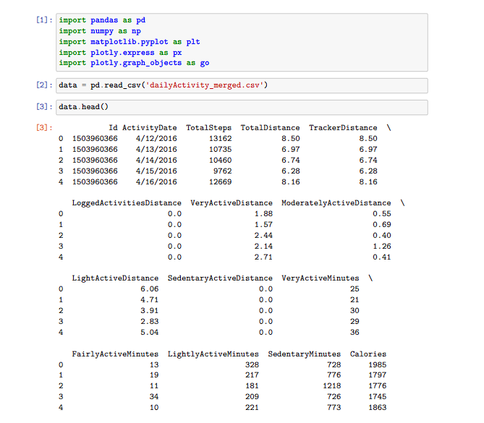

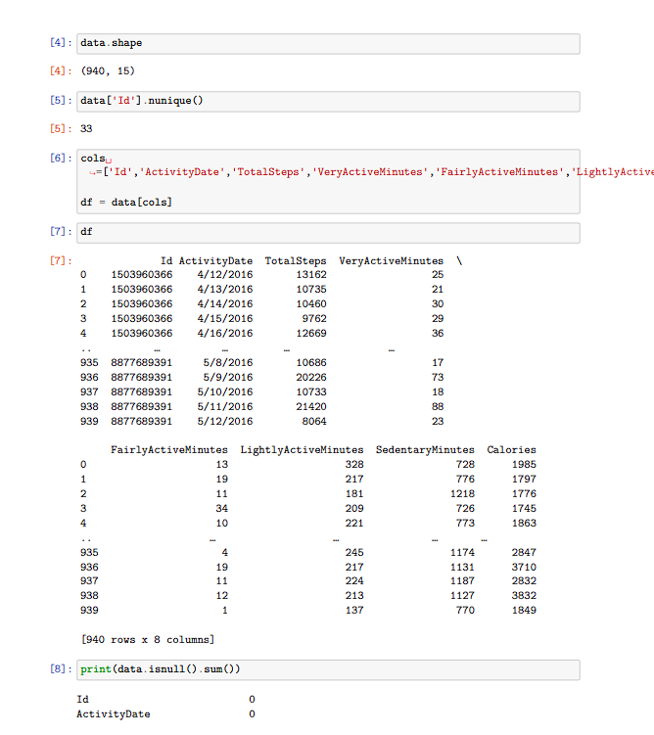

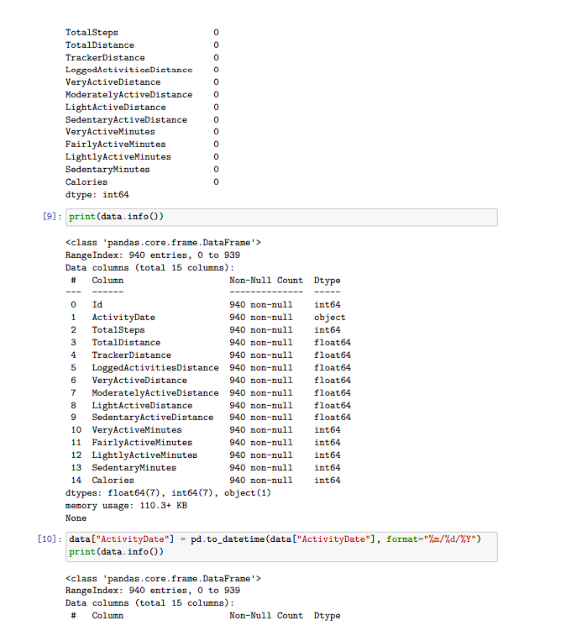

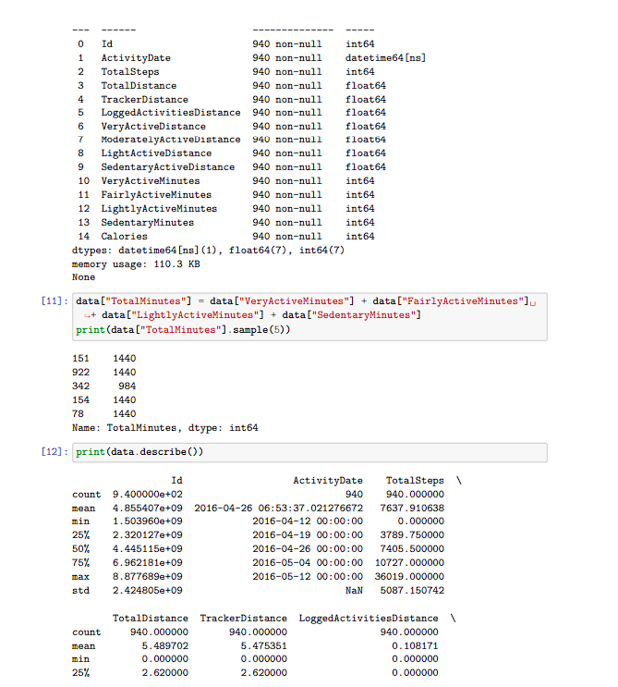

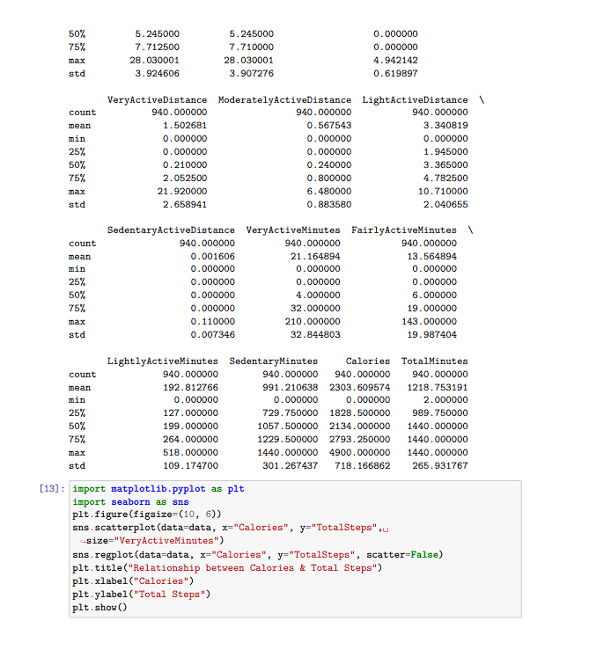

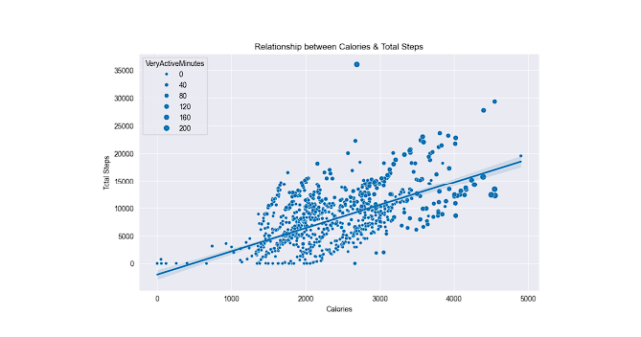

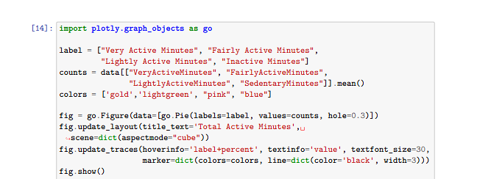

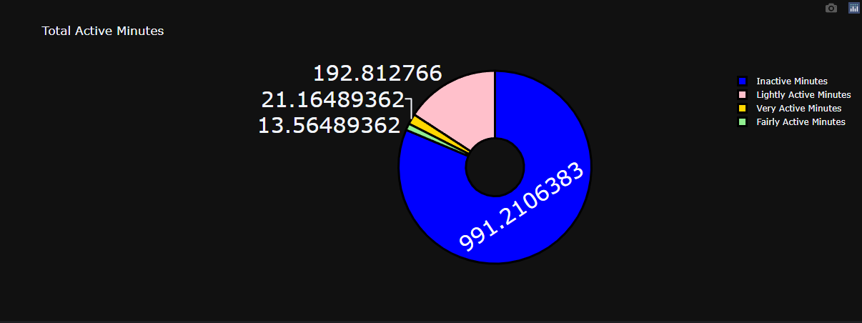

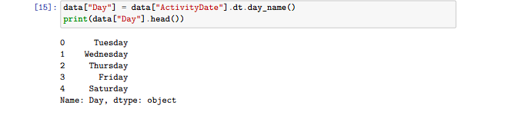

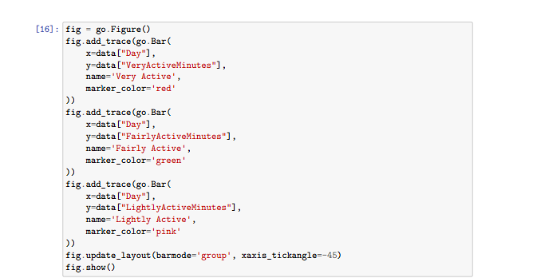

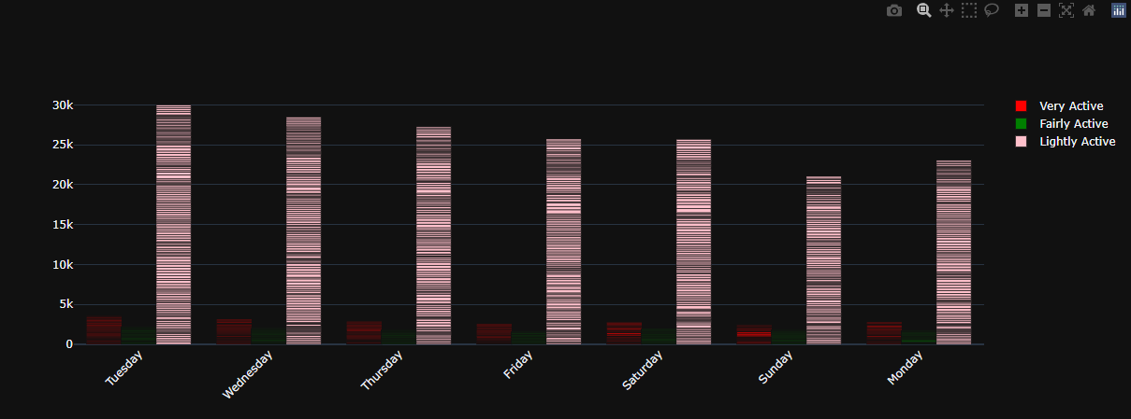

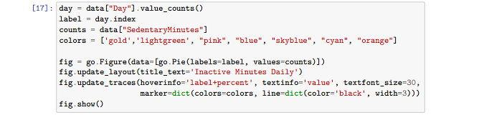

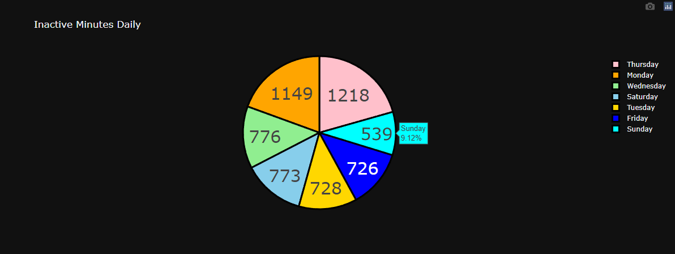

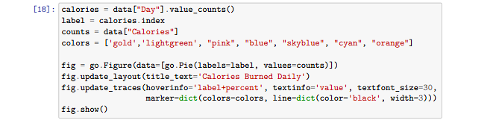

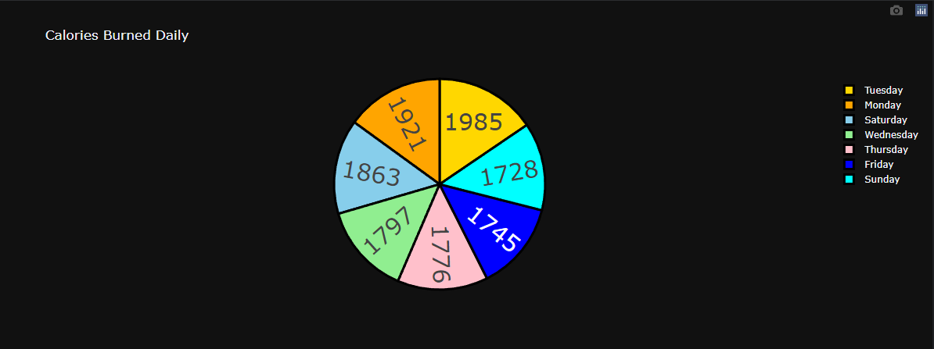

**Conclusion**

**The dataset, comprising daily activity records of individuals, offers a comprehensive glimpse into their physical activity levels, with metrics including steps taken, active minutes, sedentary time, and calories burned. With no missing values and appropriately formatted data, the analysis proceeds smoothly. Descriptive statistics unveil central tendencies and distributions of various activity metrics, while visualizations such as scatter plots and pie charts provide intuitive insights into relationships between activity levels, calories expended, and daily trends. Weekly patterns emerge as activity levels fluctuate across different days, depicted vividly through grouped bar charts. Moreover, pie charts showcase the distribution of sedentary time and calories burned throughout the week, shedding light on periods of inactivity and energy expenditure. Together, these analyses equip individuals with valuable insights to better understand their daily activity patterns, facilitating informed decisions aimed at enhancing overall health and fitness levels.**